

MATHEMATICS
Specialist Units 3 & 4
Test 2 – Functions and Sketching Graphs

Semester 1 2019

Section Two – Calculator Assumed

Time allowed for this section
Working time for this section: 26 minutes
Marks available: 26 marks

Material required/recommended for this section

To be provided by the supervisor
This Question/Answer booklet
Formula sheet

To be provided by the student
Standard items: pens, pencils, pencil sharpener, eraser, correction fluid, ruler, highlighters

Special items: drawing instruments, templates, notes on one unfolded sheet of A4 paper, and up to three calculators satisfying the conditions set by the Curriculum Council for this course.

Important note to candidates
No other items may be used in this section of the examination. It is your responsibility to ensure that you do not have any unauthorised notes or other items of a non-personal nature in the examination room. If you have any unauthorised material with you, hand it to the supervisor before reading any further.

- (5 marks)
The graph of $y=\frac{ax+b}{cx+4}$, where a and b are coefficients and c is a constant, is shown below.

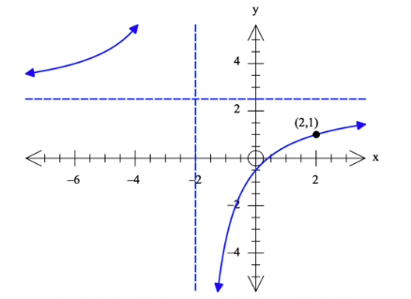

The point $(2, 1)$ lies on the graph, and the equations of its vertical and horizontal asymptotes are $x=-2$ and $y=2.5$ respectively.

Find the values of a, b and c.

- (9 marks: 4, 3, 2)
The graph of $y=f(x)$ is shown below.
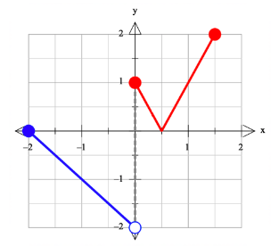

  - On the axes below, sketch the graph of $y=\frac{1}{f\left(x\right)}$.
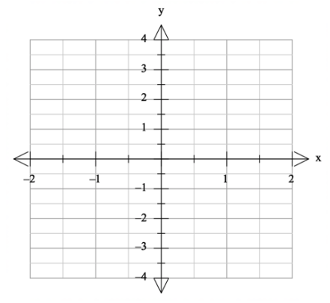

  - On the axes below, sketch the graph of $y=f\left(-\left|x\right|\right)$.
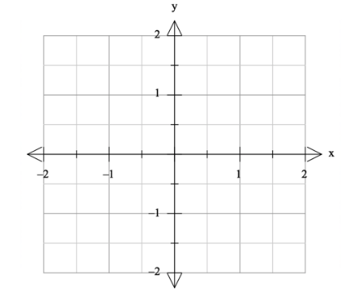

  - Solve the equation $\left|f\left(x\right)-1\right|=1.$

- (7 marks: 2, 3, 2)
The graph of the function $f\left(x\right)=-\frac{1}{2}x^{2}$, $0≤x≤2$, is shown below.
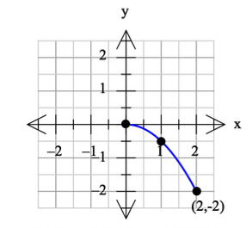

  - Sketch the graph of $y=f^{-1}(x)$ on the axes with $f(x)$ above.

  - Determine the defining rule for $y=f^{-1}(x)$ and state its domain.

  - Solve:
    - $f\left(x\right)=-\frac{3}{2}$

    - $f^{-1}\left(x\right)=1$

- (5 marks)
The graph of $y=g(x)$ is shown below. It has asymptotes at $x=-3, x=2, y=$ $-1$ . On the next set of axes draw the graph of $y=$ $\frac{1}{g(x)}$ , clearly showing any roots and asymptotes.

End of Section Two
This page has intentionally been left blank
You may use this space to extend or re-attempt an answer to a question or questions and should you do so then number the question(s) attempted and cross out any previous unwanted working.

